Hospital Analytics Report
Executive Summary:
This report presents a descriptive and exploratory analysis of a hospital management dataset containing patient, doctor, appointment, treatment, and billing records. The objective of the analysis was to evaluate overall hospital performance, identify high-performing departments and doctors, understand patient behaviour, and derive actionable insights for operational and revenue improvement. The analysis reveals strong revenue contribution from Orthopaedics and other major departments, high patient retention, balanced gender distribution, and meaningful differences across age groups, treatment types, and specialties. The report also highlights doctor-level performance and appointment patterns to support data-driven hospital management decisions. Strategic recommendations are provided to improve resource allocation, patient retention, and departmental performance.
Business Objective:
- To evaluate overall hospital performance
- To identify top-performing departments, doctors, and cities
- To analyze patient behaviour and appointment patterns
- To derive business insights for revenue optimization and service improvement
Dataset: Hospital Analytics Dataset
Data Volume Overview:
- Total records:
    - Patients: 8,000
    - Doctors: 200
    - Appointments: 25,000
    - Treatments: 18,000
    - Billing records: 25,000
- Time span: 2023–2025
- Key Departments: Orthopaedics, Dermatology, Neurology, General Medicine, Paediatrics, Oncology, ENT, Cardiology
- Key Cities: Phoenix, Miami, Dallas, Houston, Boston, Chicago, Los Angeles, New York
Limitations:
- The dataset does not include bed occupancy, discharge dates, or inpatient stay duration
- Patient satisfaction or clinical outcome measures are not available
- Billing amount is used as a revenue proxy; profit or cost margin is not included
- Doctor productivity is evaluated using appointment volume, treatment contribution, and revenue generation metrics.
Analysis Type: Descriptive & Exploratory Analysis
Tools Used: Microsoft Power BI
Hospital Dataset Attributes:
The dataset consists of five interconnected tables representing patients, doctors, appointments, treatments, and billing records.
Patient
Name | Description
Patient ID | Unique identifier for each patient
Patient Name | Name of the patient
Gender | Gender of the patient (Male/Female)
Age | Age of the patient
City | City where the patient resides
Registration Date | Date when patient registered
Doctor
Name | Description
Doctor ID | Unique identifier for each doctor
Doctor Name | Name of the doctor
Department | Department assigned (e.g., Orthopaedics, Cardiology)
Specialty | Doctor specialization
Experience | Years of experience
Treatment
Name | Description
Treatment ID | Unique identifier for each treatment
Patient ID | Links to patient
Doctor ID | Links to doctor
Treatment Type | Type of treatment (Surgery, Therapy, etc.)
Treatment Date | Date of treatment
Treatment Cost | Cost of treatment

Appointment
Name | Description
Appointment ID | Unique identifier for each appointment
Patient ID | Links to patient
Doctor ID | Links to doctor
Appointment Date | Date of appointment
Appointment Status | Completed / Cancelled / Scheduled
Reason for Visit | Purpose of visit (Checkup, Fever, etc.)
Patient Type | New / Returning patient

Billings
Name | Description
Bill ID | Unique identifier for billing record
Appointment ID | Links to appointment
Billing Date | Date of bill generation
Total Amount | Total billed amount
Payment Method | Cash / Card / Insurance
Payment Status | Paid / Pending

Data Cleaning & Preparation Summary:
- Dataset imported and structured into related tables
- Data cleaning was performed in Power Query
- Date fields were converted to proper date format
- Duplicate and inconsistent text entries were standardized
- Relationships were created among Patients, Doctors, Appointments, Treatments, and Billing tables
- Relevant calculated columns and DAX measures were added for KPI generation
- A calendar table was created to support time-based analysis
Visualizations Used:
- KPI cards for revenue, patients, treatments, appointments, and retention metrics
- Line charts for appointment and revenue trends
- Clustered bar charts for department-wise and doctor-wise comparisons
- Donut charts for gender and specialty/city contribution
- Treemap and bar charts for age-group analysis
- Matrix/table visual for top 10 doctors and reason-for-visit segmentation
Analytical Techniques Applied:
- Descriptive Analysis
- Comparative Analysis
- Trend Analysis
- Percentage Contribution Analysis
- Patient Segmentation Analysis
- Department and Doctor Performance Analysis
- KPI and DAX-based Dashboard Analysis
Key Findings:
Report 1- Executive Revenue Insights
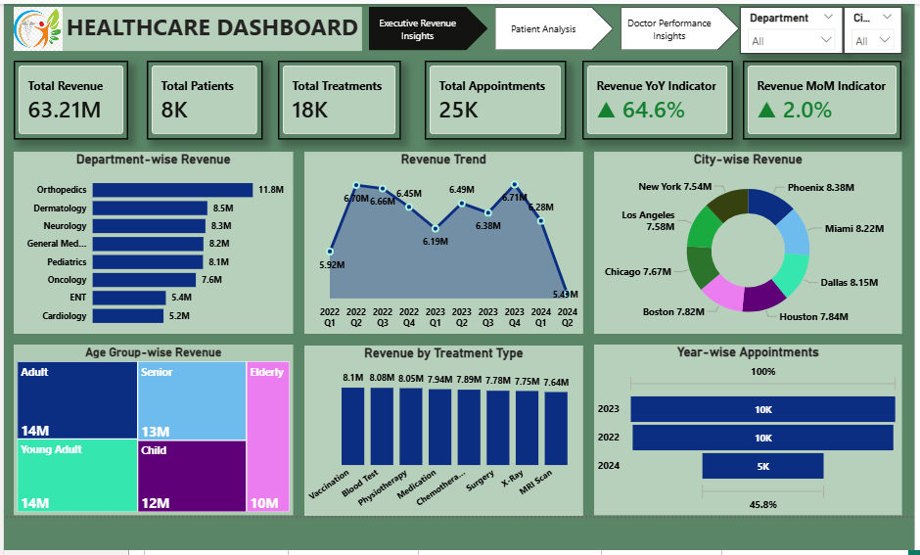
STRATEGIC INSIGHTS:
- The hospital generated 63.21M in total revenue, indicating strong overall financial performance.
- Orthopaedics is the leading revenue-generating department at approximately 11.8M, followed by Dermatology and Neurology.
- Revenue is distributed across multiple cities, with Phoenix contributing the highest city-level revenue.
- Revenue trend analysis shows positive current momentum, with YoY growth of 64.6% and MoM growth of 2.0%.
- Adult and Young Adult groups contribute strongly to hospital revenue.
BUSINESS RECOMMENDATIONS:
- Allocate more operational and promotional focus to high-performing departments such as Orthopaedics and Dermatology
- Investigate lower-performing departments for service, staffing, or demand issues
- Expand capacity planning in top-performing cities
- Monitor revenue trend changes monthly to identify slowdowns early
- Promote high-revenue treatment categories to maintain growth
Report 2 - Patient Analysis
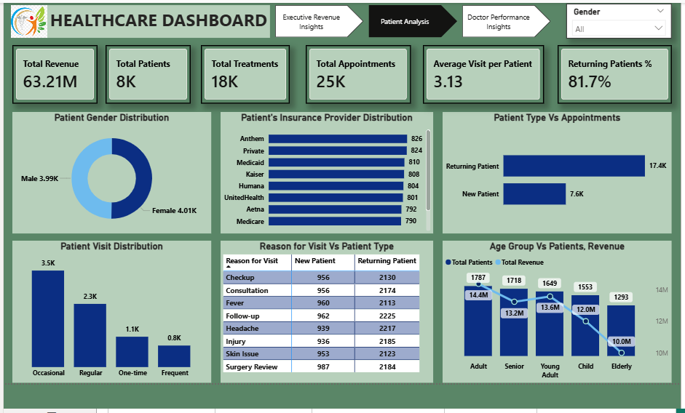
STRATEGIC INSIGHTS:
- The hospital serves approximately 8K patients and records 25K appointments, resulting in an average of 3.13 visits per patient.
- Returning patients account for 81.7% of the patient base, showing strong patient retention and repeat usage of services.
- Gender distribution is almost balanced, with a slight difference between male and female patients.
- Returning patients generate significantly more appointments than new patients.
- Insurance provider usage is spread across several providers, with no extreme concentration in a single provider.
- Adult, Senior, and Young Adult age groups contribute more strongly to patient count and revenue than Child and Elderly segments.
BUSINESS RECOMMENDATIONS:
- Strengthen patient retention programs since repeat visits already form a major part of hospital activity
- Design targeted campaigns for new-patient acquisition to balance dependency on returning patients
- Study the reasons for visit with the highest return patterns for preventive care and service bundling
- Build age-group-specific healthcare packages for Adult and Senior segments
- Analyze insurer partnerships to improve billing efficiency and patient convenience
Report 3 - Doctor Performance Insights
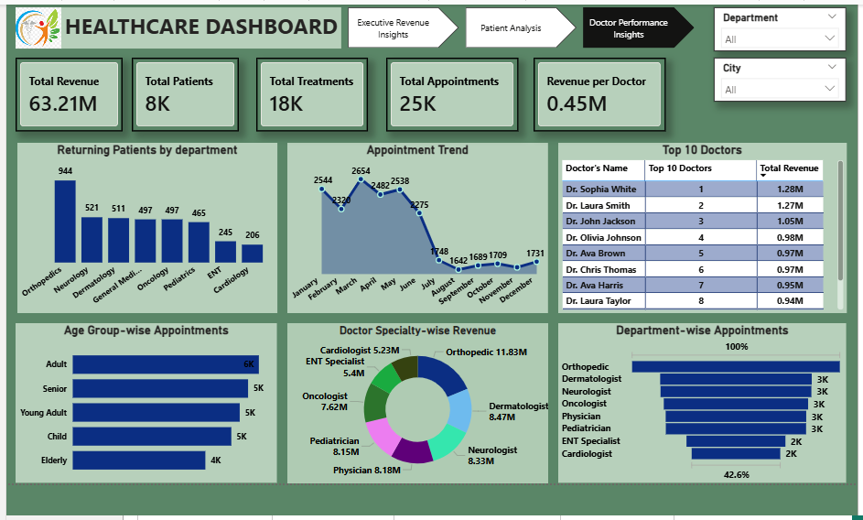
STRATEGIC INSIGHTS:
- The hospital’s doctors show measurable performance differences, with top-performing doctors contributing nearly or above 1M in revenue individually.
- The Top 10 Doctors visual highlights a small group of doctors generating a high share of doctor-level revenue.
- Specialty-wise revenue is led by Orthopaedic, followed by Dermatologist, Neurologist, Physician, and Paediatrician specialties.
- Returning patients by department are highest in departments such as Orthopaedics and Neurology, suggesting strong follow-up demand.
- Appointment trends indicate variation across the year, which can help with scheduling and staffing optimization.
Business Recommendations:
- Recognize and benchmark top-performing doctors to understand best practices
- Use appointment and revenue patterns to optimize doctor scheduling
- Provide additional support to lower-performing specialties where demand or efficiency is lower
- Expand follow-up service workflows in departments with strong repeat-patient volume
- Align staffing and specialty availability with high-demand periods
KPI Metrics:
- Total Revenue: 63.21M
- Total Patients: 8K
- Total Treatments: 18K
- Total Appointments: 25K
- Average Visit per Patient: 3.13
- Returning Patients %: 81.7%
- Revenue YoY Growth: 64.6%
- Revenue MoM Growth: 2.0%
- Top Revenue Department: Orthopaedics
- Highest Revenue City: Phoenix
Conclusion:
The hospital management analysis demonstrates strong overall operational and financial performance. The dashboard highlights healthy revenue generation, high patient retention, and meaningful performance differences across departments, cities, age groups, and doctors. Orthopaedics emerges as the leading department by revenue, while returning patients account for a major share of total appointment activity. Doctor-level and specialty-level analysis further reveal opportunities for performance benchmarking and better staffing decisions. Overall, the hospital shows strong service demand and stable growth potential, with clear opportunities for revenue optimization, resource planning, and improved patient engagement.

